The topic for the 15th All Japan National Debate Tournament in Shiga
第15回 全国高校生英語ディベート大会（滋賀県開催）論題

1 March 2020

HEnDA Chief Judge: Yoshiro Yano

Topic resolution (Tentative wording)

Resolved: That the Japanese Government should ban production and sales of fossil-fueled cars, including hybrid cars, by 2035.

日本政府は，（ハイブリッド車も含む）化石燃料車の製造と販売を2035までに禁止すべきである。

Tentative Definitions:
1. “Fossil-fueled cars” assumes all passenger cars which use fossil fuel. “Fossil fuel” in this sense includes petroleum (or its derivations such as gasoline, diesel fuel, etc.), natural-gas, and coal (and their derivations as well). “Hybrid cars”, should also be the target of the ban as long as it has fossil-fueled engines. (Technically, so called “plug-in hybrids” are more like electric cars, but to make things simple, they should be counted as “hybrids” and should be part of the ban, as long as they also have gas engines.)
2. Alternatives for “fossil-fueled” passenger cars are not defined here. They should not be limited by plans. (Meaning, it is up to predictions using evidence: Electric cars, hydrogen cars, etc. may be the front runners.)
3. “Production and sales” should mean production and sales in Japan. The usage of fossil-fueled cars is not automatically banned at the moment of 2035.
4. Production and sales of fossil-fueled (non-passenger) trucks, special vehicles are not included in the ban (thus out of this debate topic).

NB: The topic wording and definitions may be changed later.
Any suggestions for the official debate topic wording are welcome.
(Fossil-fueled or fossil-fuelled (Brit?) or fossil fueled (no hyphen): What do you think is the best?)

Additions or changes to the tentative definitions, if necessary, will be supplied after Spring tournaments in the coming weeks (Hopefully, if the corona craze settles down). If you have any opinion on how we should limit or define the topic, please send your opinion to Yano (email: yano@tamacc.chuo-u.ac.jp) by March 31st.

※注意 論題の文言は修正される可能性があります。
要項に載せる正式の論題のため，ご意見等よろしくお願いします

暫定的定義は，必要に応じて修正します。論題での議論を絞る定義についてご意
見がありましたら3月31日までに矢野まで(email: yano@tamacc.chuo-u.ac.jp)お
願いします。

HOW THIS TOPIC WAS CHOSEN 論題選定の経緯

The HEnDA committee selected four potential topic areas from your
suggestions in mid-February, and called for public comments, and then a
opinion poll whether you approve four potential topics.

A) ENVIRONMENT - Resolved: That the Japanese Government should ban production and sales of fossil-fuelｌed cars, including hybrid cars, by 2035.
B) PENAL SYSTEM - Resolved: That Japan should abolish capital punishment.
C) FAMILY/GENDER - Resoved: That the Japanese government should obligate every male full-time worker with a newly-born child to take child care leave.
D) FOREIGN AFFAIRS - Resoved: That Japan should terminate the Japan-U.S. Security Treaty.

The result of the poll was: (Total number of votes N = 79)

A) ENVIRONMENT 41 (51.9%)
D) FOREIGN AFFAIRS 34
B) PENAL SYSTEM 32
C) FAMILY/GENDER 22
NONE OF THE ABOVE 1

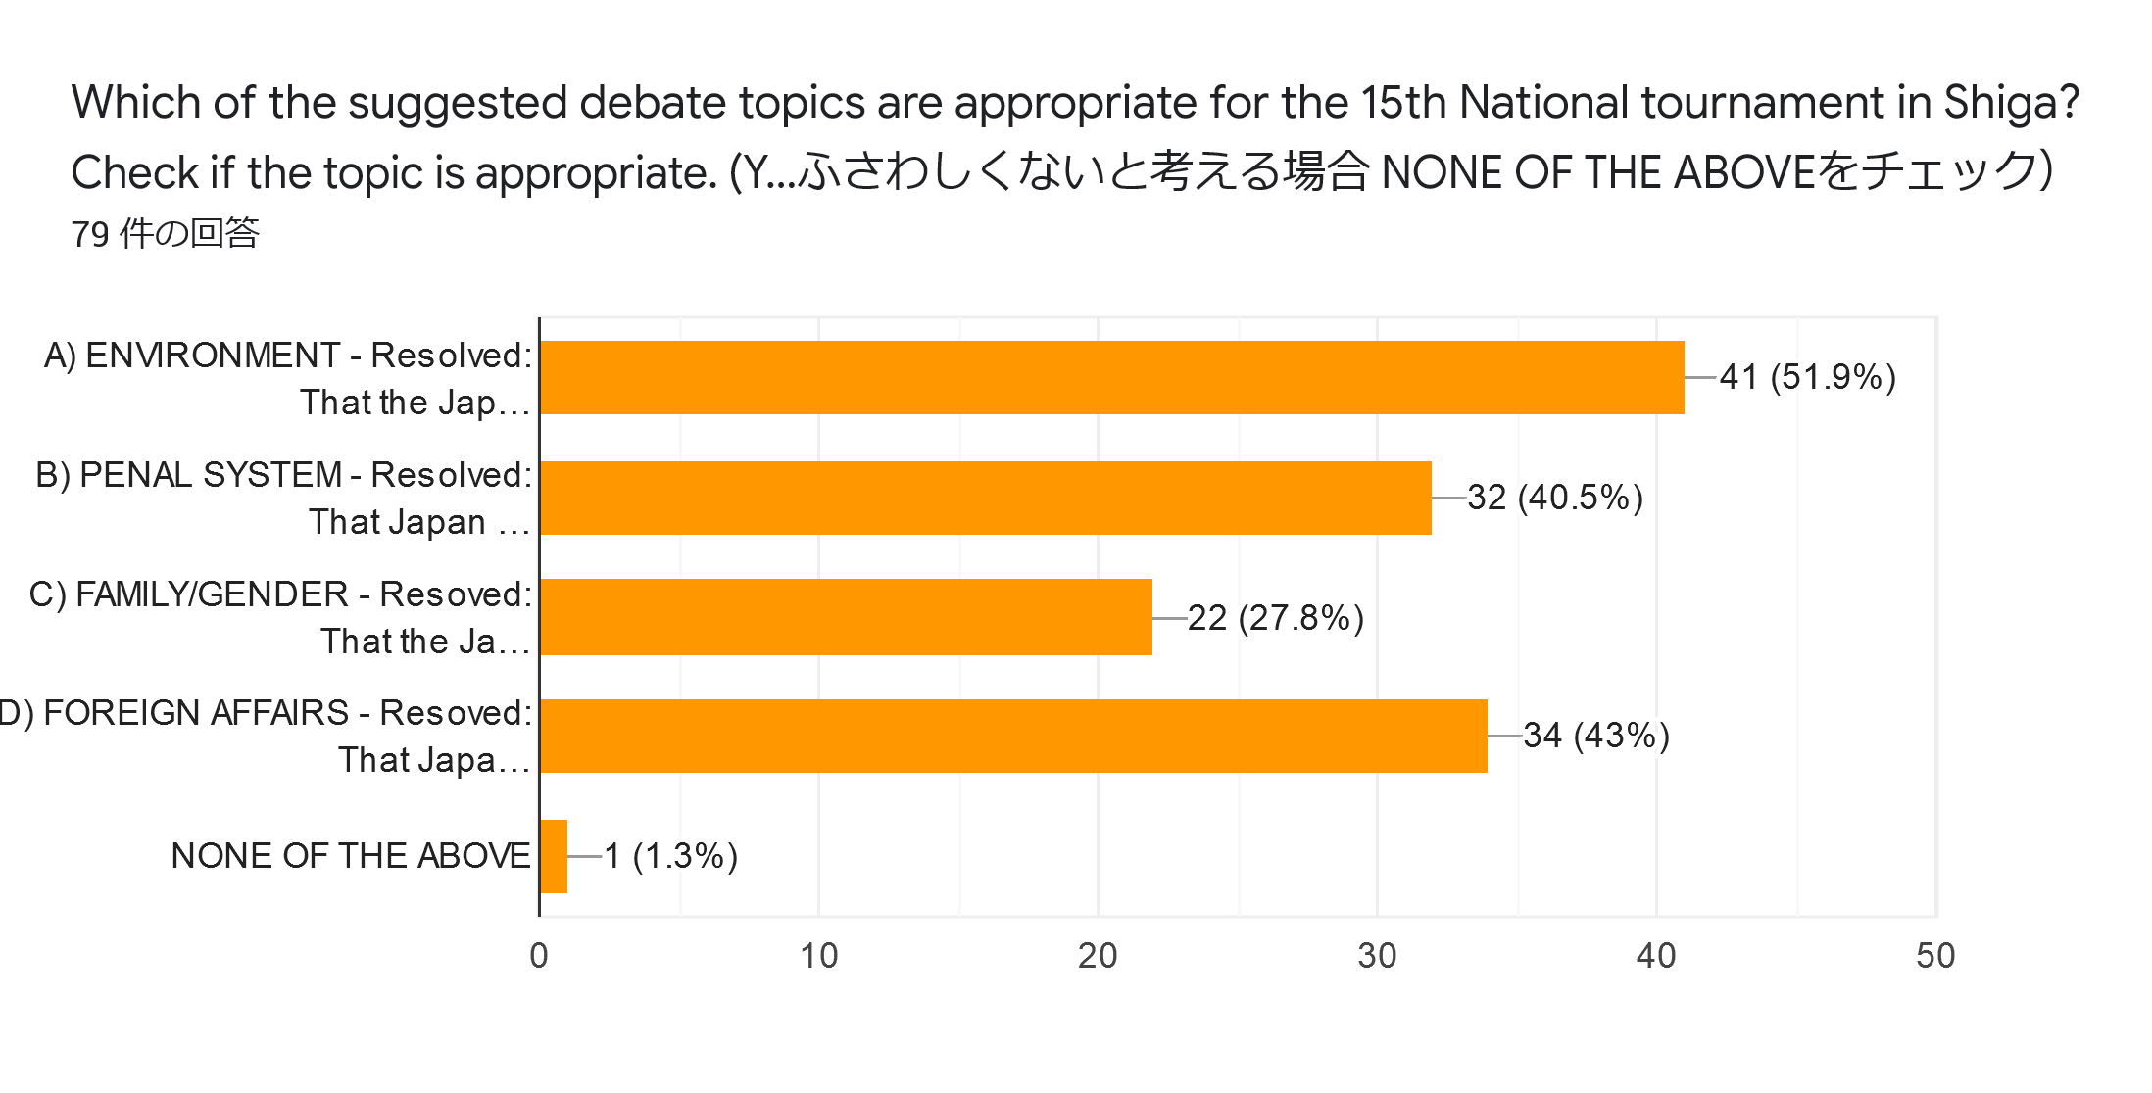
Thank you all for the wonderful and inspiring suggestions, votes, and very useful comments!

YY

