The Topic for the 16th All Japan National Debate Tournament "Online"
第16回 全国高校生英語ディベート大会（オンライン開催）論題
(Tentative Wordings and Definitions)
3 March 2021

HEnDA Chief Judge: Yoshiro Yano

Debate Topic (Tentative wording)
Resolved: That the Japanese Government should relocate the capital functions out of Tokyo.
日本政府は，首都機能を東京の外に移転すべきである。是か非か。

Background of the topic
Debates concerning the relocation of the capital functions out of Tokyo, were much more serious during the 1980s and the 90s. The Diet has adopted the resolution to relocate capital functions in the year 1990, and there is even an Act for the Relocation of the Diet and Other Organizations that was passed in 1992. It is unclear what the current government’s official position is; other than the planned Bunka-cho relocation (mentioned below in 4.), the resolution and the Act seems to be somehow virtually forgotten. But this does not mean that the topic’s relevance has diminished, or the topic is outdated. Rather, the problem of excessive concentration of social functions and population in the Tokyo metropolitan area may arguably be one of the most important issues that decide the long term future of Japan. Obviously, concerns over the prevention of future disasters, caused not just by earthquakes but also by pandemics, add renewed relevance in debating this topic.

Definitions (Tentative)

1. “out of Tokyo”:
Affirmative side (AFF) should propose where the “new capital” should be (the “Plan”), early in the constructive speech. AFF must select from one of the three areas that were proposed by the Prime minister’s advisory council in 1999: (1) the Tochigi-Fukushima area, (2) the Gifu-Aichi area, and (3) the Mie-Kio area.
(https://www.mlit.go.jp/kokudokeikaku/iten/English/qa/chapter03.html)
If the AFF fails to designate the area of the new capital, the debate should proceed (by default) assuming that the capital functions would be relocated to (2) the Gifu-Aichi area. [You know, the 1st HEnDA tournament was held in Gifu! This provision is truly kind of tentative. The latitude of selecting the designated new capital may be either relaxed or narrowed after we have looked at the early debates.]

2. “relocate”:
It should be assumed that a new capital will be constructed with a smart, ecological city construction plan. The vacated governmental buildings and sites in Tokyo should be assumed to be either sold (to the private sector), reused (as public museums, theaters, etc.), or razed (making more parks, for disaster prevention etc.).
It should be assumed that the relocation process will take around 10-15 years.

3. “capital functions”:
“Capital functions” includes the state government central offices (the state administrative branch, the Ministries, the Agencies), the Diet (the state legislative branch: The House of Representatives, the House of Councilors and their relevant offices), and the center of juridical functions (the Supreme Court and its organizations).
“Capital functions” should not include the imperial palace (see 4. below), nor the cultural/educational institutions run by the state (such as theaters, museums, national universities etc. Of course, the Ministry of Education, Culture, Sports, Science and Technology itself should be part of the above relocation).
The AFF may not propose to limit or make exceptions to the above “capital functions”: They should defend the position that all of these functions should be relocated to the designated “new capital.”
The AFF may not add plans to relocate other economic/societal functions in Tokyo. However, the demographical/economic impact of the relocation of capital functions are up to debate (using predictions based on evidence).

4. Exceptions
a) ADs and DAs concerning the relocation of the Imperial Palace and the emperor’s acts of state should not be debated within this topic. To be precise, the Japanese Constitution Art. 6 and 7, defines the emperor’s functions and acts of state: Appointment of the Prime Minister and the Supreme Court Chief Judge, legal promulgations, attestations of ambassadors, etc. However, we will not argue about where these ceremonial functions should take place, as they are trivial matters compared to the central questions of the topic, that is, whether we should let the proceeding concentration (of nearly everything!) in Tokyo continue or not.
b) The Agency for Cultural Affairs (Bunka-cho) is planned to be relocated to Kyoto in 2022. Please consider it also an exception: ADs and DAs concerning the relocation of Bunka-cho is out of this debate topic.

5. Negative side (NEG) position:
The NEG should support a policy that denies further relocation of capital functions outside of Tokyo. The AFF and NEG positions do not change even if the actual Japanese government should announce to relocate the capital functions (before the National tournament).

NB: The topic wording and definitions may be changed later.
Any suggestions for the official debate topic wording are welcome.
Additions or changes to the tentative definitions, if necessary, will be supplied after some actual debates (the Spring tournaments, renshukais) by around mid May. If you have any opinion on how we should limit or define the topic, please send your opinion to the chief judge Yano (email: yano@tamacc.chuo-u.ac.jp).

※注意 論題の文言は修正される可能性があります。要項に載せる正式の論題のため，ご意見等よろしくお願いします。今回は，英語での暫定的定義のみになります。日本語版も３月中に公開します。春に行われるディベートの趨勢などを観て５月中にまた必要に応じて修正を発表することにします。論題での議論を絞る定義についてご意見がありましたら矢野まで(email: yano@tamacc.chuo-u.ac.jp)お願いします。

HOW THIS TOPIC WAS CHOSEN 論題選定の経緯
The HEnDA committee selected four potential topic areas from around 20 or so suggestions in mid-February, and called for an opinion poll on whether to approve four potential topics.
The result of the poll was: (Total number of votes N = 90)
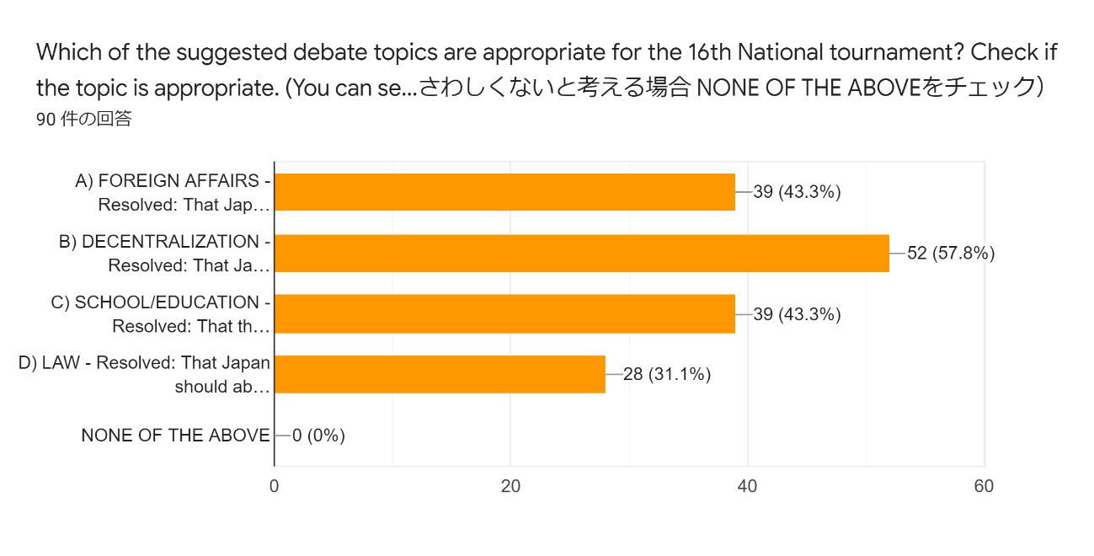
The Relocation/Decentralization topic was the most approved (57.8%)
Thank you all for the wonderful and inspiring suggestions, votes, and very useful comments! (We have incorporated the suggestions in the tentative definitions already.)

