The Topic for the 16th All Japan National Debate Tournament "Online"
第16回 全国高校生英語ディベート大会（オンライン開催）論題
(Wording and Definitions)
15 Nov. 2021

HEnDA Chief Judge: Yoshiro Yano

* NB: There is no change in the topic wording or definitions from the initial announcement in March.
However, to avoid the debaters’ additional (and often unfair) “plans” that were sometimes seen in local tournaments, some clarifications are added. (See section Additional Clarification)

Debate Topic
Resolved: That the Japanese Government should relocate the capital functions out of Tokyo.
日本政府は，首都機能を東京の外に移転すべきである。是か非か。

Background of the topic
Debates concerning the relocation of the capital functions out of Tokyo, were much more serious during the 1980s and the 90s. The Diet has adopted the resolution to relocate capital functions in the year 1990, and there is even an Act for the Relocation of the Diet and Other Organizations that was passed in 1992. It is unclear what the current government’s official position is; other than the planned Bunka-cho relocation (mentioned below in 4.), the resolution and the Act seems to be somehow virtually forgotten. But this does not mean that the topic’s relevance has diminished, or the topic is outdated. Rather, the problem of excessive concentration of social functions and population in the Tokyo metropolitan area may arguably be one of the most important issues that decide the long term future of Japan. Obviously, concerns over the prevention of future disasters, caused not just by earthquakes but also by pandemics, add renewed relevance in debating this topic.

Definitions

1. “out of Tokyo”:
Affirmative side (AFF) should propose where the “new capital” should be (the “Plan”), early in the constructive speech. AFF must select from one of the three areas that were proposed by the Prime minister’s advisory council in 1999: (1) the Tochigi-Fukushima area, (2) the Gifu-Aichi area, and (3) the Mie-Kio area.
(https://www.mlit.go.jp/kokudokeikaku/iten/English/qa/chapter03.html)
If the AFF fails to designate the area of the new capital, the debate should proceed (by default) assuming that the capital functions would be relocated to (2) the Gifu-Aichi area. [You know, the 1st HEnDA tournament was held in Gifu!]

2. “relocate”:
It should be assumed that a new capital will be constructed with a smart, ecological city construction plan. The vacated governmental buildings and cites in Tokyo should be assumed to be either sold (to the private sector), reused (as public museums, theaters, etc.), or razed (making more parks, for disaster prevention etc.).
It should be assumed that the relocation process will take around 10-15 years.

3. “capital functions”:
“Capital functions” includes the state government central offices (the state administrative branch, the Ministries, the Agencies), the Diet (the state legislative branch: The House of Representatives, the House of Councilors and their relevant offices), and the center of juridical functions (the Supreme Court and its organizations).
“Capital functions” should not include the imperial palace (see 4. below), nor the cultural/educational institutions run by the state (such as theaters, museums, national universities etc. Of course, the Ministry of Education, Culture, Sports, Science and Technology itself should be part of the above relocation).
The AFF may not propose to limit or make exceptions to the above “capital functions”: They should defend the position that all of these functions should be relocated to the designated “new capital.”
The AFF may not add plans to relocate other economic/societal functions in Tokyo. However, the demographical/economic impact of the relocation of capital functions are up to debate (using predictions based on evidence).

4. Exceptions
a) ADs and DAs concerning the relocation of the Imperial Palace and the emperor’s acts of state should not be debated within this topic. To be precise, the Japanese Constitution Art. 6 and 7, defines the emperor’s functions and acts of state: Appointment of the Prime Minister and the Supreme Court Chief Judge, legal promulgations, attestations of ambassadors, etc. However, we will not argue about where these ceremonial functions should take place, as they are trivial matters compared to the central questions of the topic, that is, whether we should let the proceeding concentration (of nearly everything!) in Tokyo continue or not.
b) The Agency for Cultural Affairs (Bunka-cho) is planned to be relocated to Kyoto in 2022. Please consider it also an exception: ADs and DAs concerning the relocation of Bunka-cho is out of this debate topic.

5. Negative side (NEG) position:
The NEG should support a policy that denies further relocation of capital functions outside of Tokyo. The AFF and NEG positions do not change even if the actual Japanese government should announce to relocate the capital functions (before the National tournament).

ADDITIONAL Clarifications (Nov. 15)
Basic rule for interpreting HEnDA topics (not just this year, but every year):
1. If it is not EXPLICITLY written in the above HEnDA definitions, debaters cannot add any new assumptions (additional “plan”, limitation, specification, etc.), nor should the judge assume that such new assumptions can justify or refute Advantages or Disadvantages by themselves.
2. In other words, if it is not explicitly written in the above HEnDA definitions, you must argue and prove it (with evidence)

Here are the additional “plan”, limitation, specification, etc. examples that should NOT be provided by the debaters (The list is not exhaustive; basically, there is NO room for additional “plans” other than mentioned above.)

1. “out of Tokyo”:
×Debaters should not further narrow down or expand the three areas that were proposed by the Prime minister’s advisory council in 1999: (1) the Tochigi-Fukushima area, (2) the Gifu-Aichi area, and (3) the Mie-Kio area. For example, it is not allowed to show plans like “We propose to move only in Fukushima prefecture” or “We propose to move to certain XX area.”
If the debate is to focus (geographically) on the supposed new capital whereabouts, the debaters should argue with evidence, referring (for example) to the relocation plans that were considered in the past (1990s), when the three areas were proposed.
(See for example, https://www.pref.mie.lg.jp/KIKAKUK/HP/shuto/27263024004.htm)

2. “relocate”:
×Debaters should not add assumptions about the new city construction: For example, designating the budget limit or adding specifications about the construction.
Even though “the new capital will be constructed with a smart, ecological city construction plan” it is just a “construction plan” and obviously, it can be challenged that the new capital construction will cause environmental damage.
×Debaters should not designate the usage of “the vacated governmental buildings and cites in Tokyo”: For example you should not add plans like, “we propose to make former governmental buildings as parks”. Debaters should make predictions (based on evidence) whether it will be “sold, reused, or razed”.
×Debaters should not change or designate the relocation timeline “that the relocation process will take around 10-15 years.”: For example, delaying, prolonging, or shortening the relocation timeline. (You should not say that the relocation construction will start later, say, in 2030.)

3. “capital functions”:

4. Exceptions
×Debater should not add other capital functions in the relocation (like “we will also make the business sector move out of Tokyo”, etc.) or make additional exceptions (like “we will not move the Supreme Court”, etc.).

HOW THIS TOPIC WAS CHOSEN 論題選定の経緯
The HEnDA committee selected four potential topic areas from around 20 or so suggestions in mid-February, and called for an opinion poll on whether to approve four potential topics.
The result of the poll was: (Total number of votes N = 90)
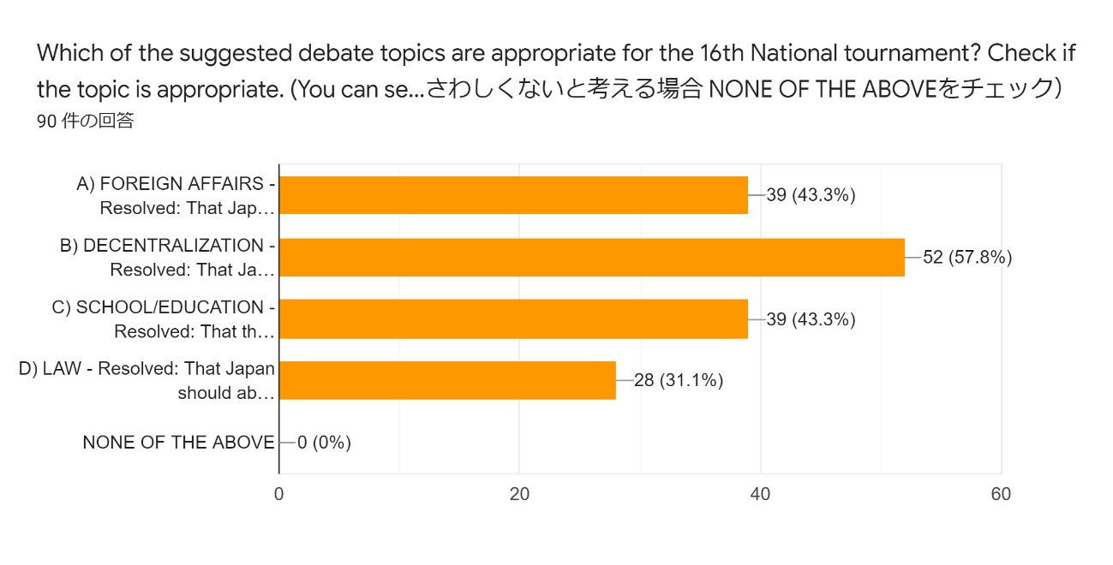
The Relocation/Decentralization topic was the most approved (57.8%)
Thank you all for the wonderful and inspiring suggestions, votes, and very useful comments! (We have incorporated the suggestions in the tentative definitions already.)

